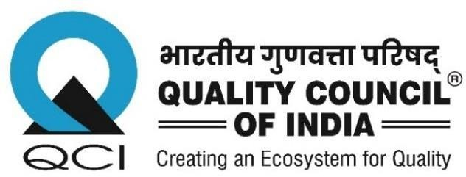
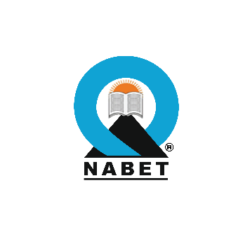

SCHEME FOR ACCREDITATION OF GWCO CONSULTANT ORGANIZATION

EMPANELMENT OF ACCREDITATION AND TECHNICAL COMMITTEE MEMBERS FOR THE GWCO SCHEME

National Accreditation Board for Education & Training (NABET), a constituent board of the Quality Council of India (QCI) is operating the accreditation scheme for GWCO consultant organizations. Ministry of Jal Shakti (MOJS)/CGWA has made it mandatory for GWCO Consultants to get accredited under this Scheme. Details of the Scheme are available on the QCI website www.qcin.org.
Consultant Organizations seeking accreditation under the Scheme need to meet the requirements of having experts with defined qualifications and experience to be involved for preparing Comprehensive Hydrogeological Reports. Accreditation is granted by the Accreditation committee, which comprises of eminent persons. Apart from granting the accreditation to the consultant organization, the committee provides clarifications to some aspects of the Scheme as necessary from time to time. While Technical Committee guides NABET in developing the Scheme as well as the assessment process taking into consideration the feedback received from stakeholders/Accreditation Committee/Assessors et al.
NABET proposes to empanel Accreditation and Technical Committee Members for the Scheme who meet the following requirements of qualification and experience –

Educational qualification –
  - The members must be at least holders of a Master’s (post-graduate) degree/ M. Tech in either subject- Hydrogeology/ Geology/ Applied Geology/Geophysics/ Water Resources Management from a UGC/AICTE recognized University/ Institution or equivalent.
  - The members must be at least holders of a Master’s (post-graduate) degree/ M. Tech in either subject- Hydrogeology/ Geology/ Applied Geology/Geophysics/ Water Resources Management from a UGC/AICTE recognized University/ Institution or equivalent granted by a university established or incorporated by or under a Central Act, A Provincial Act or a State Act including any institutions recognized by the University Grants Commission under Section 4 of the University Grants Commission Act, 1956 (3 of 1956) or any equivalent qualification granted by any university or institute outside India and recognized by Government of India.

  - Membership of a professional body in her/his area/s of expertise will be an added qualification.

Experience –

  - They should have minimum Professional experience 15 years overall work experience in their professional fields after the completion of above-mentioned qualifying degree Assessment field as a consultant/regulator/client/research worker/teacher/NGO.
  - Should have a good understanding of the Hydrogeological Report preparation process and Ground Water related applicable rules & regulations
  - Should have held senior positions in decision making level

- Engagement- Member shall be appointed for a period of two (2) years extendable by another two years.
For Accreditation Committee Members- In a month there may be 1-2 meeting (Physical/Video Conference) or as and when required
For Technical Committee Members- Twice/Thrice in a year (Physical/Video Conference) or as and when required.

Note:

- The expert should not be involved in any capacity in the process of Preparing Hydrogeological Reports and must submit an undertaking to this effect.
- Candidate must also declare to the Board about association of his/her and/ or immediate family relative/s with any of the Ground Water Consultant Organization (GWCO) that can affect the impartiality of the assessment process.
- No telephone enquiries will be solicited.

Please send a soft copy of your resume in the attached format (Sub: Empanelment of Accreditation Committee and Technical Committee Members for Accreditation Scheme for GWCO Consultant Organizations) with a recent passport-size photograph and 3 references (with their contact details and your consent to contact them) to C.E.O. NABET. NABET proposes to make a roaster of such applications. These will be processed further on half yearly/yearly as per the requirements.

Click here for Resume format

For further details, please contact
National Accreditation Board for Education and Training (NABET), Quality Council of India
World Trade Centre, K –100, First Floor,
Nauroji Nagar, Safdarjung Enclave, New Delhi-110029
Tel: +91-11-42600800, 11-42600820, 11-42600806
Website: www.qcin.org; Email: jagminder.nabet@qcin.org,
manila.nabet@qcin.org

